**Computer network**

**lecture 1 & 2**

What is computer network and what is the network architecture?

2 or more computers connected by a link (each called a node)

2 or more networks connected by 2 or more nodes

Benefits:

Sharing resources

Transferring files

Communication Model in Networks

Source ->Transmitter ->Transmission system ->Receiver ->Destination

How to network Connect?

Direct connectivity: point-to-point source ->link → destination

multi-point mainframe ->link->many destinations

Indirect connectivity:

Switched( switches)

Internetworking (routers)

How to classify networks?

Based on transmission media: Wired (coaxial cables, fiber-optic cables) and Wireless

Based on network size: LAN and WAN (and MAN)

Based on management method: Peer-to-peer and Client/Server

Based on topology (connectivity): Bus, Star, Ring,...

Explain transmission media?

Guided

Twisted-Pair:

* Two insulated copper wires arranged in regular spiral pattern (to decrease interference)
* Number of pairs are bundled together in a cable
* Limited in terms of data rate (up to 64 Kbps) and distance
* Cheap, most widely used

Unshileled Twisted Pair (UTP):

* subject to external inference
* used in telephone wires

Shielded Twisted Pair (STP)

* Reduce interference
* More expensive
* Max length 100m (before signals weakened)

Coaxial Cables

* Can be used over longer distances
* Common in TV cables
* Less susceptible to interference than twisted pair
* Requires repeaters every few kilometers for digital transmission
* Has less attenuation

Unguided

Transmission and reception are achieved using an antenna

* Transmitter sends out the electro-magnetic signal into the medium
* Receiver picks up the signal from the surrounding medium

What are the different types of networks? (LAN, WAN, MAN,....)

Local Area Networks (LAN)

* Nodes within small geographic region (home, business, school)
* Limited by no. of computers and distance covered

Wide Area Networks (WAN)

* Uses long-range telecommunication links to connect 2 or more LANs/computers housed in different places far apart.
* Ex: Internet

Metropolitan Area Networks (MAN)

Network Management (architecture)

Peer-to-peer (P2P): Most common in home networks

Client/server: Most common in Internet

Describe network topologies?

Mesh

* Every node connected to every other node
* Link only carries data between two devices only
* Expensive (more cabling) with many redundant connections

Star

* Each computer has a cable connected to a single point (hub, switch or router)
* All signals transmission through the hub; if down, entire network down
* Depending on the intelligence of hub, two or more computers may send message at the same time
* Inexpensive and easy to install
* Used mainly in LANs

Bus

* Simple and low-cost
* Only 1 cable, but terminators required at each end.
* Only one computer can send messages at a time
* Whole system breaks if main cable breaks

Ring

* Every node has exactly 2 neighbors
* All messages travel in one direction
* Typical way to send data: Token passing
* Expensive and difficult to install
* Offers high bandwidth

What is the Internet and how it works?

millions of connected computing devices: hosts = end systems

running network apps

communication links( fiber, copper, radio, satellite)

routers: forward packets (chunks of data)

Protocols control sending, receiving of msgs (TCP-IP-HTTP)

How can computers communicate? (protocols)

Through computer network protocol:

protocols define format, order of msgs sent and received among

network entities, and actions taken on msg transmission, receipt

ISO/OSI Reference Model

International Standards Organization ( ISO ) :is a multinational body dedicated to worldwide agreement on international standards.

Open Systems Interconnection ( OSI ) model: model composed of 7 layers

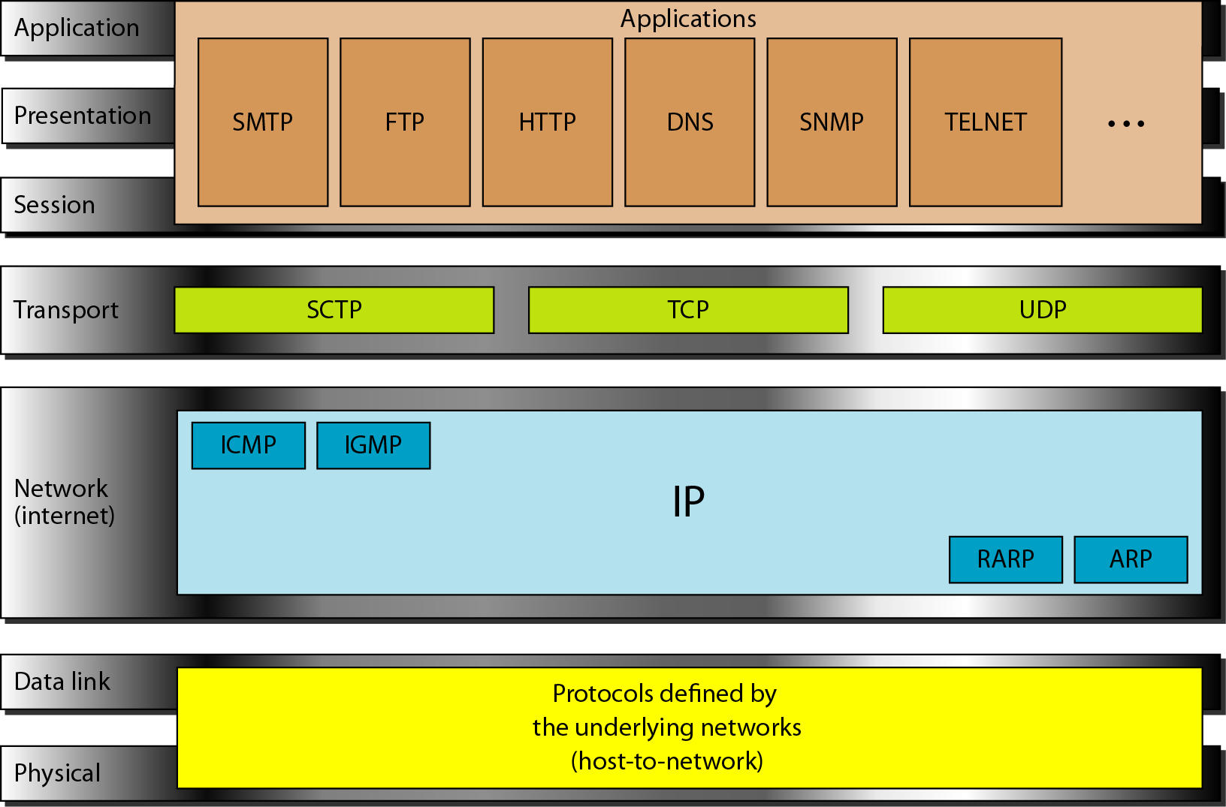

**lecture 3**

Network Core

■ Mesh of interconnected routers sharing the infrastructure

■ How to build a network core: (how data is transferred through the net?)

Circuit switching: dedicated circuit per call: telephone net

Packet-switching: data sent thru net in discrete “chunks”

Circuit switching phases

* Call set-up: end-to-end resources (e.g. bandwidth) reserved for the call before sending any data
* Data transfer
* Disconnection: resources released after finishing data transfer and disconnecting the circuit.
* No sharing of resources

What if request fails? Session is refused (busy tone on the phone)

Packet Switching

* No call setup before data transfer
* Data is divided into packets that are sent independently (header contains control info, e.g., source and destination addresses)
* At each node the entire packet is received, stored, and then forwarded (store-and-forward)
* No capacity is allocated
* On demand use of resources: If you need more, you get more, If you need less, you get less

What if link is full? Queue the packet

What if queue is full? Drop the packet

Four Sources of Packet Delay

|  |  |
| --- | --- |
| 1. Nodal processing: | • check bit errors  • determine output link |
| 2. Queueing | • time waiting at output link  for transmission  • depends on congestion level  of router |
| 3. Transmission delay: | R=link bandwidth (bps)  L=packet length (bits)  time to send bits into link = L/R |
| 4. Propagation delay: | d = length of physical link  s = propagation speed in medium  (~2x108 m/sec)  propagation delay = d/s |

d (nodal)=d (proc) + d (queue) + d (trans) + d (prop)

Example : LEC/p21

Packet switching versus circuit switching

Packet switching:

* Most suitable for bursty traffic
* No call setup
* Efficient use of resources

-- Protocols needed for reliability and congestion control

-- No performance guarantee (still working on it)

Take Home Quiz

d(trans) = 30Mbits/10Mbps = 3 second  
d(prop)= 10,000km / 2 * 10^8 meters/sec = 0.05 sec  
d =d(trans)+d(prop) = 3 + 0.05 = 3.05 sec

How many bits will the source have transmitted when the first bit arrives at the destination?

When the first bit arrives at the destination → propagtion delay

d(prop) * 10Mbps= 0.05 * 10Mbps = 50.000 bits

Application Layer What Will We Study?

HTTP: Hyper Text Transfer Protocol

**lecture 4**

Web Caches (proxy server)

Instead of direct connection to web server, the browser may connect with the proxy server.

What for?

* Limiting the traffic to the remote web pages. Web content is stored in proxy cache (reduce traffic on institution’s access link)
* Controlling access to web resources
* Reduce response time for client request

Web Caches (proxy server): How it Works?

User sets browser: Web accesses via cache

Browser sends all HTTP requests to the proxy server

Proxy server (listening usually to port 8080)

check: if not contain the requested page

Do : proxy connects to page

soter the reply in cashe

return answer to cient

object in cache: cache returns object

SMTP 3 major components:

1. User Agent(mail reader)
2. Mail server
3. SMTP protocol

SMTP: Simple Mail Transport Protocol

* Application layer protocol for sending messages between mail servers
* Uses TCP connection
* Has 2 sides: client and server.
* Command/response interaction
* Messages must be in 7-bit ASCII
* SMTP uses persistent connections

MIME: Multipurpose Internet Mail Extensions

For sending non-ASCII content (images, video, arabic characters,..)

Additional headers declare MIME content type

Two key MIME headers: Content-type, Content-transfer-encoding

Mail access protocols

SMTP: delivery/storage to receiver’s server

Mail access protocol: retrieval from server (POP- IMAP- HTTP)

**lecture 5**

DNS: Domain Name System

map between IP addresses and name

From slides

Transport Layer

* Logical communication between applications on 2 different machines (end-to-end protocols)
* Network layer delivers packets to a specific destination host, while transport protocol distinguishes between different destinations (applications) within the same host

Transport Control Protocol(TCP)

* Reliable
* In order delivery
* Flow control
* Congestion control
* Needs connection set up

User Datagram Protocol (UDP)

* Unreliable
* Unordered delivery
* Best effort service

Transport Layer Ports

Each process that wants to communicate with another process identifies itself to the TCP/IP protocol suite by a 16-bit port number.

There are two types of port:

* Well-known: belong to standard servers, for example, web server uses port 80. Well-known port numbers range between 1 and 1023
* Ephemeral: used by clients. Each client process is allocated a port number for as long as it needs it by the host it is running on. Ephemeral port numbers have values in the range 1024 to 65535

UDP: User Datagram Protocol

“best effort” service, UDP segments may be:

* lost
* delivered out of order to app

Connectionless:

* no handshaking between UDP sender, receiver
* each UDP segment handled independently of others

Why is there a UDP?

* no connection establishment (which can add delay)
* simple: no connection state at sender, receiver
* small segment header
* no congestion control: UDP can blast away as fast as desired

UDP Packet lec5/p37

Transport Control Protocol (TCP )

Main Functions:

Reliable and In-order delivery

* Packets are all delivered and in the same order they were sent

Flow Control

* Sending rate not to exceed receiving processing rate

Congestion Control

* Sending rate not to exceed the slowest link on the path to destination

TCP Properties

Connection-based transmission:

* Before transmission, TCP establishes a connection between source and destination

Stream orientation:

* TCP is a byte stream not message stream. Every byte has its own sequence number

Full duplex connection

* Concurrent transfer in both directions

Buffered Transfer:

* Buffer data until enough to form one segment (Maximum Segment Size MSS), or divide large data into smaller segments

**lecture 8/9**

Routing Algorithms Classification

Global

* Least-cost path is calculated using complete, global knowledge about the network
* All routers have complete graph (topology, costs)
* “Link state” algorithms (OSPF)

Decentralized

* Calculations are carried out in an iterative, distributed manner.
* Router knows link costs to physically connected adjacent nodes
  + Run iterative algorithm to exchange information with adjacent nodes
  + “Distance vector” algorithms (RIP)

The Link Layer

Data link layer: “link”Move datagrams from one node to adjacent node over a link

hardware addresses used in frame headers to get datagram from one interface to another physically-connected interface (same network)

Network layer: Source-to-destination delivery

Data link layer: Hop-to-Hop delivery

ARP: Address Resolution Protocol